Documentation

Technical Report: Performance Evaluation of GPU Accelerated 2D Convolution

This report details the comparative performance analysis between a Sequential CPU-based convolution and a Parallel GPU-based (CUDA) implementation. The objective is to quantify the acceleration provided by NVIDIA’s CUDA architecture and identify the data scale at which parallelization becomes beneficial.

1. Architectural Overview

Convolution is a computationally intensive operation requiring N * M * K^2 operations.
- Sequential Implementation: Executed on a single CPU thread. It processes pixels in row-major order, utilizing standard cache hierarchies but limited by sequential execution.
- CUDA Implementation: Utilizes a "Strip-Mining" approach. The input matrix is divided into horizontal segments (chunks) to optimize VRAM utilization. Each pixel calculation is mapped to a discrete GPU thread, organized into 16x16 thread blocks.

2. Comparative Benchmark Results

The following table summarizes execution times recorded for a 3 * 3 kernel (K=3) across varying matrix dimensions (N * M).

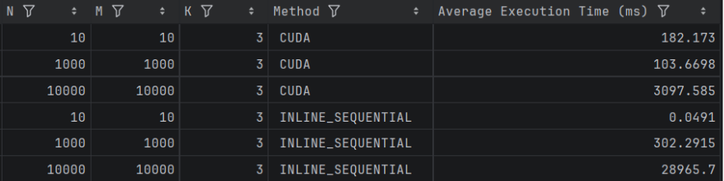

3. Quantitative Analysis of Performance

- Initial Latency and API Overhead

At the 10 * 10 scale, the CPU implementation is vastly superior. This is attributed to CUDA API overhead. The time required for context initialization, device memory allocation (cudaMalloc), and the high-latency PCIe data transfer far exceeds the negligible time required for 100 arithmetic operations.

- Parallel Efficiency and Scaling

As the workload increases to 10^6 elements, the GPU begins to demonstrate efficiency. The massive throughput of the GPU's Streaming Multiprocessors (SMs) starts to offset the data transfer latency.
At the 10,000 * 10,000 scale, the parallel implementation achieves a 9.35x speedup. The CPU becomes bottlenecked by the instruction cycle count and frequent memory access, whereas the GPU's architecture hides memory latency by executing thousands of threads concurrently.

4. Implementation Consistency and Data Integrity

To maintain accuracy during in-place modifications, the CUDA implementation employs two critical synchronization mechanisms:
- Halo Overlap: Each chunk includes a boundary "halo" (radius of K / 2) to ensure that pixels at the edge of a strip have access to neighboring data.
- Seam Management: A secondary CPU buffer saves original pixel values at the "seams" (chunk borders) before they are modified. This ensures that when the next chunk begins processing, it has access to the original, un-convolved neighbors.

5. Final Findings
The data confirms that the performance benefit of CUDA is proportional to the arithmetic intensity and data volume of the task.
- Small-Scale Workloads: GPU acceleration is counter-productive due to fixed overhead costs.
- Large-Scale Workloads: GPU acceleration provides a critical performance gain, reducing execution time from nearly 30 seconds to approximately 3 seconds.
For high-resolution image processing and large-scale matrix operations, the CUDA implementation is the optimal choice for high-throughput environments.

